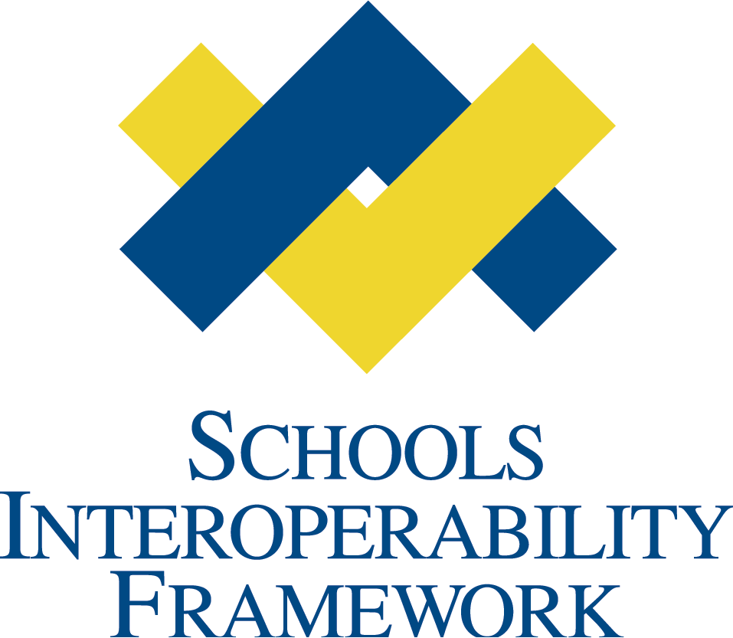

Web Services Project Team

SIF 2.5 Testing Document
V1.0
VERSION CONTROL
Draft Specification Document Version Control
Version | Date: | Author/Organization: | Comments
V1.0 | 01/05/2011 | Andrew Elmhorst | Testing Plan created

Testing Overview
This test will consist of a set of message exchanges between mock agents and mock ZISs. The intent is to test the capability of the XML messages defined in the SIF 2.5 Web Transport to ensure the following outcomes:
- Basic SOAP connectivity between a Microsoft .Net based client and a Java-based server
- Basic SOAP connectivity between a Java-based client and a Microsoft .Net based server
- Verify mandatory header information is able to be conveyed and parsed
- Verify basic System Control messages are able to be sent and received
- Verify provisioning messages are able to be sent and received
- Verify data objects are able to be conveyed in request/response and events
- Verify SOAP faults are able to be returned and parsed
- Verify Pull mode is able to be effectively used
- (Optionally) Verify SIF Zone Service messaging
- All messages exchanged should be logged and compiled into a zip file for analysis by anyone interested after the test
- Extra Credit: Verify one or more of these tests with an automated SOAP test toolkit

Test Details
Only HTTP will be tested. The test will consist of 4 participant nodes, organized into two pairs. Pair 1 will test a java client invoking a .Net Server. Pair 2 will test a .Net client invoking a Java server.

Testing Form Data

ITEM | APPLICATION RESPONSE
1.1. Application Date
1.2. Work Group (Author of Object) | Web Services Project team
1.3. Work Group Leader/Sponsor | Andrew Elmhorst / Ron Kleinman
1.4. Objects for Testing | SIF Web Services Transport 2.5
- First Agent selected for Testing (Java mock agent)  (Developer Organization and Authorized Representative) | TBD
- First ZIS selected for Testing (.Net Mock ZIS)  (Developer Organization and Authorized Representative) | TBD
- Second Agent selected for testing (.Net Mock agent)  (Organization Name and Authorized Representative) | TBD
- Second ZIS selected for testing (Java Mock ZIS)  (Organization Name and Authorized Representative) | TBD
- Testing Site | Virtual
- Testing Site Type (Showcase, Production, Connect-A-Thon) | Testing Level 3

1) Use Cases used for Testing Object

USE CASE (S) NAME | USE CASE NUMBER | USE CASE REFERENCE
System Provisioning | 1
System Control | 2
Request/Response | 3
Events | 4

2) Test Cases used for Testing Object
The following assertions are done on each test. These assertions ideally should be done by code, but if not, they can be verified manually.
Server assertions:
- Verify all mandatory SIF SOAP Headers
- Verify all mandatory WS-Addressing Headers
- Verify that the soap body root element is what was expected for the message call
Client assertions:
- Verify all mandatory SIF SOAP Headers
- Verify all mandatory WS-Addressing Headers
- Verify HTTP status code
- Assert that the return body root element is what was expected for the message call

TEST CASE (S) NAME and NUMBER | Pair 1 | Pair 2 | TEST CASE REFERENCE
1. Register with ZIS |  |  | Client sends a register message to the Server. Base Assertions. Verify that a ZoneID is returned
2. Send SIF Ping |  |  | Base Assertions
3. Send SIF Ping and receive SOAP Fault |  |  | An Error is thrown any time the SourceID is equal to “Olympus”  Base Assertions + That the server returned a SOAP Fault with a SIF Category of 11 (System) and a SIF Code of 1 (Generic)
4. Send SIF Event |  |  | Base Assertions. Server verifies that data object was received.
5. Send SIF Event with another object |  |  | Base Assertions. Server verifies that data object was received
6. Send SIF Event with Error |  |  | Base Assertions. If Event is sent with FoodserviceMilkSales, the server returns a soap fault with a SIF Category of 9 and a SIF Code of 3
7. Send SIF Request |  |  | Base Assertions.
7. Send SIF Request with error |  |  | Base Assertions. If Request is sent with FoodserviceMilkSales, the server will return a soap fault with a SIF Category of 8 and a SIF Code of 4 (No Provider)
8. Send SIF Response Packet |  |  | Base Assertions. Server verifies that packet elements are present and correct, and that message references some source message by message ID. Server verifies that data was received and able to be parsed
9. Send SIF Response Packet error |  |  | Server verifies that error is present and SIF Response is closed correctly. SIF Category will be 8 and SIF Code will be 9 (Unsupported Query)
10. Send GetMessage with return message |  |  | Base Assertions. Client verifies that message was returned
11. Send GetMessage empty queue |  |  | Base Assertions. Client verifies that it was able to determine that there were no messages in the queue
12. Send GetMessage with fault |  |  | Base Assertions. Client verifies fault it received from Server
13. Send Immediate Ack |  |  | Base Assertions. Server verifies it received Immediate ack
14. Send Error Ack |  |  | Base Assertions. Server verifies that it received an error acknowledgement from agent and was able to identify both the error and which message it was associated with
15. (Optional) Send Notify |  |  | Base Assertions. Server verifies that packet elements are present and correct, and that message references some source message by message ID. Server verifies that service elements were received and able to be parsed
16. (Optional) Send Notify error |  |  | Server verifies that error is present and SIF Notify is closed correctly
17. (Optional) Send ServiceInput |  |  | Base Assertions. Server verifies that packet elements are present and correct, and that message references some source message by message ID. Server verifies that service elements were received and able to be parsed
18. (Optional) Send ServiceInput error |  |  | Server verifies that error is present and SIF Service Input is closed correctly
19. (Optional) Send ServiceOutput |  |  | Base Assertions. Server verifies that packet elements are present and correct, and that message references some source message by message ID. Server verifies that service elements were received and able to be parsed
20. (Optional) Send ServiceOutput error |  |  | Server verifies that error is present and SIF ServiceOutput is closed correctly

3) Test Script Procedures Log

Pair 1 (Java Client and .Net Server)

OBJECT TEST NUMBER  1 – Initial Test  2 – Retest  3 – Retest | DATE OF TEST | TEST ADMINISTRATOR | RESULT- PASS | RESULT-ERROR | REASON FOR ERROR
1 – Initial Test
1 - Retest

Pair 2 (.Net Client and Java Server)

OBJECT TEST NUMBER  1 – Initial Test  2 – Retest  3 – Retest | DATE OF TEST | TEST ADMINISTRATOR | RESULT- PASS | RESULT-ERROR | REASON FOR ERROR
1 – Initial Test
1 - Retest

Result Table
Object Name | WorkGroup /TF Sponsor | WorkGroup/TF Lead | LEVEL OF TESTING PASSED | DATE OF TEST COMPLETE | COMMENTS
SIF Web Services Transport | Infrastructure Working Group | Andrew Elmhorst / Ron Kleinman | Level 3 | xx/xx/xxxx | Testing completed due to the ZIS going to sleep. All planned use cases and test cases were invoked.  Xx issues/discussion points came up during the testing and/or conversation around the testing. These will be reviewed on the next Web Services PT call

